Code

//To implement a switch case

1.

#include<stdio.h>

int main(){

int a;

do{

printf("Enter the day of the week as a number from 1-7\n");

scanf("%d",&a);

switch(a){

case 1:printf("Its a Sunday\n");

break;

case 2:printf("Its a Monday\n");

break;

case 3:printf("Its a Tuesday\n");

break;

case 4:printf("Its a Wednesday\n");

break;

case 5:printf("Its a Thursday\n");

break;

case 6:printf("Its a Friday\n");

break;

case 7:printf("Its a Saturday\n");

break;

case 0:printf("Exiting.....");

break;

default:printf("Invalid number enter again!\n");

}

}while(a!=0);

return 0;

}

Output:

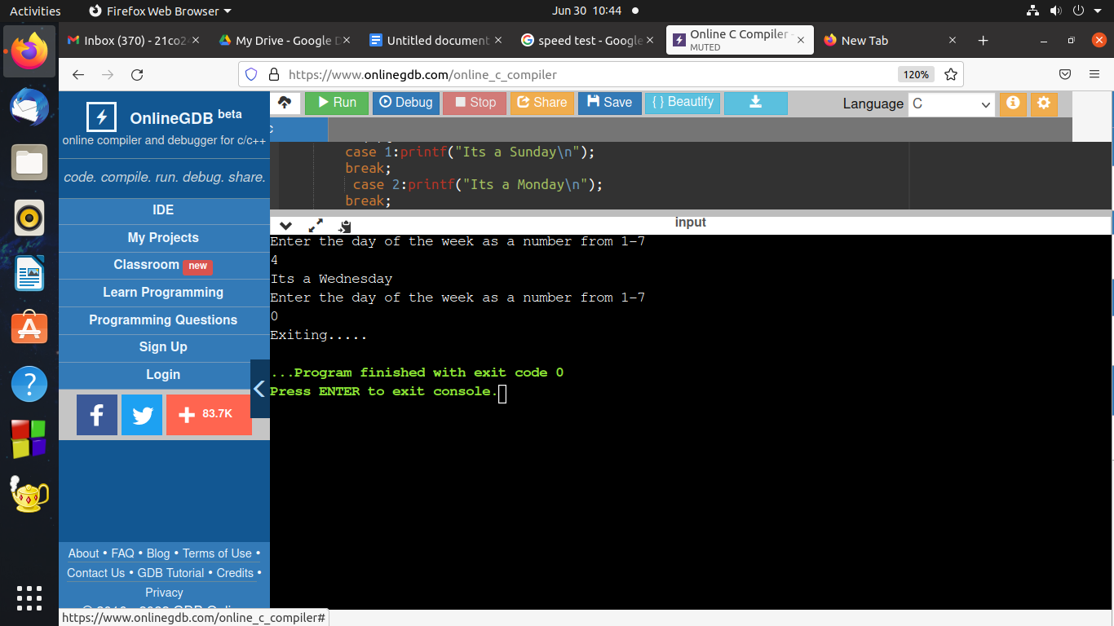

2.

#include<stdio.h>

void main(){

int n,i,a=0,b=1,c,fact=1;

printf("Enter the number n\n");

scanf("%d",&n);

printf("Enter from one of the following options\n");

printf("1.Factorial 2.Fibonacci \n");

scanf("%d",&i);

switch(i){

case 1: for(int j=1;j<=n;j++)

fact=fact\*j;

printf("The factorial of the number is %d\n",fact);

break;

case 2: for(int j=1;j<=n;j++)

{

c=a+b;

printf("%d\t",a);

a=b;

b=c;

}

break;

default :printf("The option is wrong\n");

}

}

Output:

